PRODUCT TEARDOWN
Vocallabs.ai
AI Voice Agents · India-First · Full-Stack
Product Intern Assignment · May 2026

5 Sharp Feedbacks · Observed → Problem → Ship
Spanning GTM/ICP · UX · Features · Competitor Positioning · Collaborations

Company Snapshot:

Company | Vocallabs.ai
Founded | co-founded by Mritunjoy Das, Nileesh Kumar, Rag Sanil , 2024, Bengaluru (IIT Alumni)
Category | AI Voice Agents — Sales, Support, Bookings
Model | Sales-led / Demo-gated (no self-serve pricing)
Moats | India-first tuning · Full-stack ownership · Data flywheel
Competitors | Bolna, Sarvam, Yellow.ai, Gnani.ai, Retell AI, VAPI, SquadStack, Synthflow AI
Industries | Telecom, Retail, Real Estate, Healthcare, Logistics
Key Products | AI Voice Agents, Call Flow Builder, Voice Analytics, SDK/n8n/Chrome Ext

Research basis: Website (vocallabs.ai), Android app (Play Store), GitHub repo, Crunchbase, LinkedIn, blog posts, competitor landscape research (Bolna, Sarvam, Yellow.ai, Caller Digital), and direct exploration of the product flow as a prospective SMB customer.

Prioritisation at a Glance:
The 5 feedbacks span all 5 product pillars and are ordered by business impact × implementation speed.
Feedback | Pillar | Impact | Effort | When
1 — No Self-Serve / Pricing Wall | GTM & ICPs | High | High | Ship Now
2 — ICP Messaging Undifferentiated | GTM & ICPs | High | Med | Ship Now
3 — No Live Demo / Sandbox | UX & Features | High | High | Ship Now
4 — Analytics Buried, No ROI Story | Features | Med | High | Next Quarter
5 — Missed Partner / Integration GTM | Collaborations | Med | Med | Next Quarter

Competitor Positioning Snapshot:

Feature Vocallabs Bolna Retell AI
Public Pricing No Yes Yes
Sandbox No Yes Yes
Developer Docs Visibility Low High High
India Accent focus Yes Partial No

The 5 Feedbacks:
1. [GTM & ICPs] No Self-Serve Pricing — Killing Top-of-Funnel Conversion
(a) OBSERVED | (b) PROBLEM
Every path on vocallabs.ai ends at either 'Book a Demo' or 'Contact Us.' There is no pricing page, no free trial, and no indication of cost structure. A prospective SMB founder or ops lead who lands on the site cannot evaluate fit without scheduling a call — a friction that most will not bother with.  Screenshot-  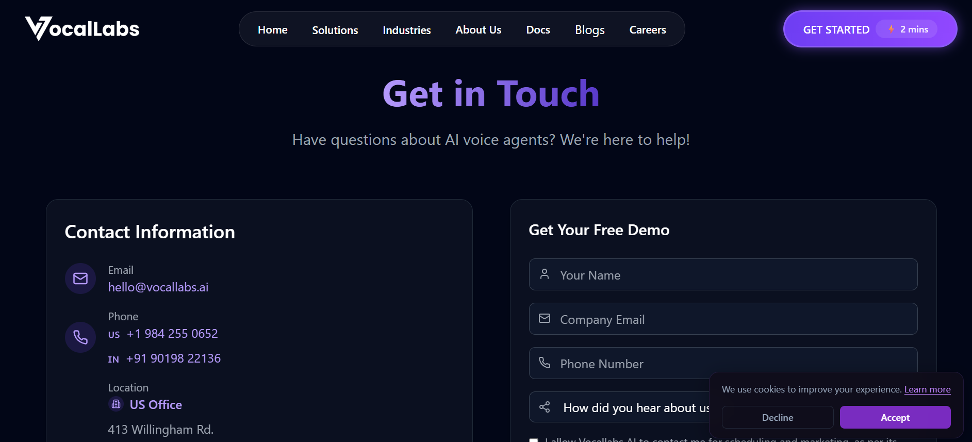  Vocallabs.ai routes users directly toward demo booking without exposing pricing, self-serve onboarding, or trial access. The absence of a pricing page or sandbox increases evaluation friction for SMB and developer audiences. | India's high-intent B2B buyers (real estate ops heads, D2C founders, clinic managers) self-research before any human touchpoint. When pricing is gated, 60–80% of qualified visitors bounce rather than book a demo. Vocallabs is self-funding growth through sales bandwidth, which is expensive to scale and ignores the developer/prosumer segment that could become organic advocates. Competitors like Bolna (~₹5.52/min) and Retell AI publish clear per-minute pricing, making competitive evaluation trivially easy against Vocallabs.
(c) SHIP INSTEAD
Add a Pricing page with 3 tiers — a free sandbox (100 minutes/month for testing), a Pay-as-You-Go plan (transparent INR per-minute rate), and an Enterprise/custom tier. Even a 'Starting from ₹X/min' signal dramatically reduces sales friction. This does not require abandoning the demo motion for enterprise — it adds a self-serve lane that runs in parallel. Reference: Bolna, Retell, and Synthflow all do this successfully.

2. [GTM & ICPs] ICP Messaging Is Generic — 'Sales, Support & Booking' Serves No One Specifically
(a) OBSERVED | (b) PROBLEM
The homepage headline reads 'Deploy and Scale Voice AI.' The use-case categories — sales, support, bookings — are identical to every competitor in the space (Yellow.ai, Gnani.ai, Bolna). There are no named verticals on the homepage or in the nav. The careers page mentions telecom, retail, and real estate as target industries, but this never surfaces in the main product marketing.  Screenshot-  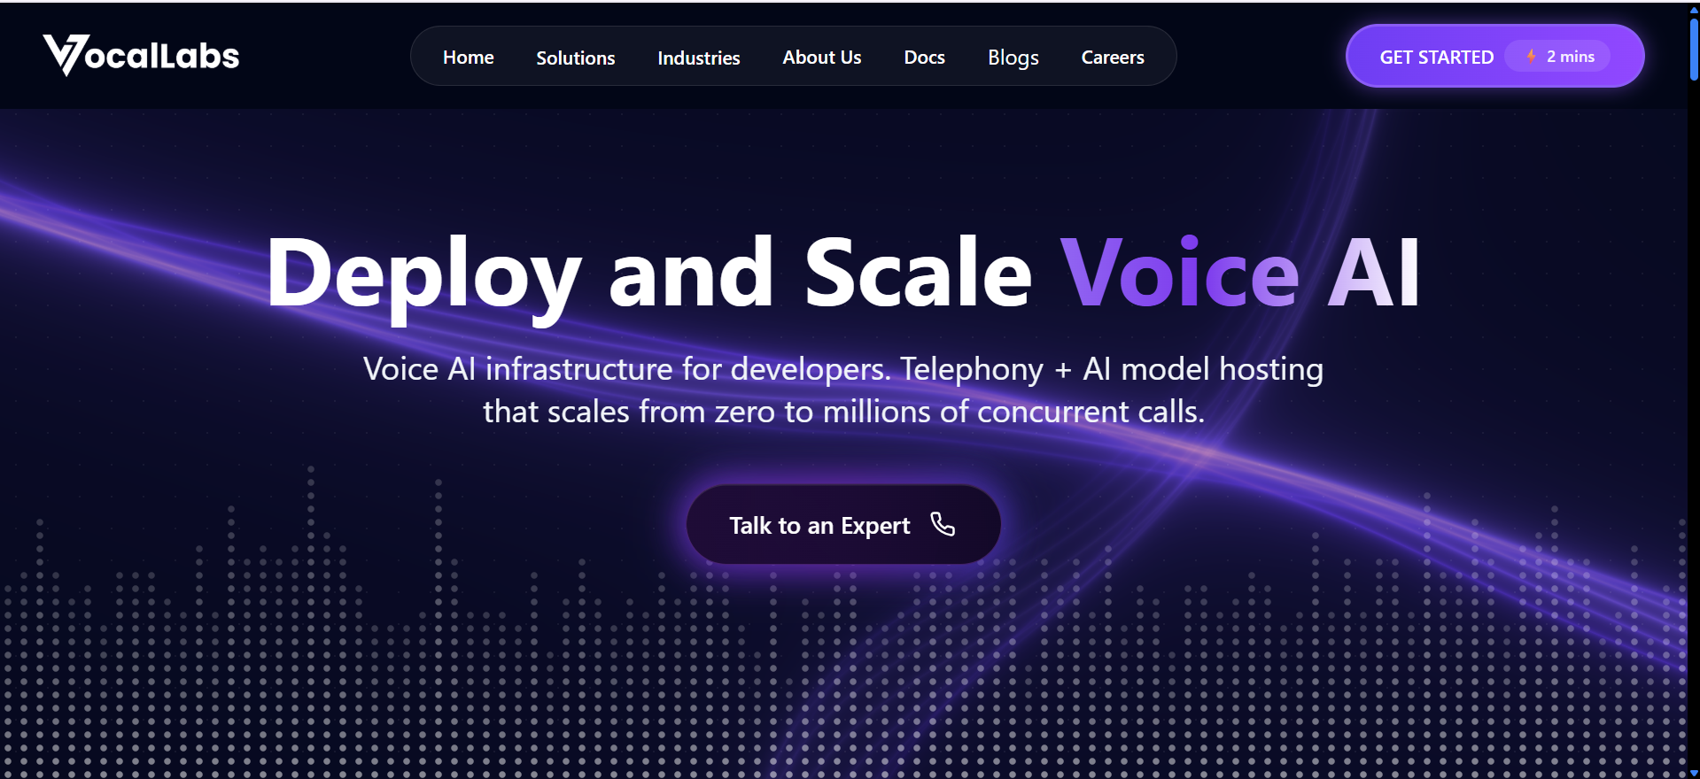  Vocallabs.ai positions itself broadly around “Deploy and Scale Voice AI” and general-purpose voice infrastructure capabilities. While the platform references use cases such as sales, support, and bookings, the homepage and navigation do not clearly communicate which industries or customer segments the product is specifically optimized for. As a result, key ICPs such as real estate operations teams, D2C brands, or healthcare providers cannot immediately identify whether the platform is purpose-built for their workflows, reducing differentiation and increasing evaluation friction. | When a real estate ops manager or a D2C brand's CX lead arrives at the site, they cannot quickly answer 'Is this built for me?' Generic positioning forces every visitor into a from-scratch evaluation loop. It also means paid campaigns can't be targeted — you can't write an ad for 'real estate booking automation' if your landing page talks about generic transformation. Vocallabs has India-first tuning as a moat, but that moat is invisible from the website.
(c) SHIP INSTEAD
Build 3–4 vertical-specific landing pages: (1) Real Estate — 'Automate site visit bookings and follow-up calls for your sales team', (2) D2C / E-commerce — 'Handle COD verification and order status calls at scale', (3) Healthcare / Clinics — 'Appointment confirmation and no-show reduction'. Each page should show a screenshot of the Call Flow Builder with a vertical-specific script, a 60-second audio demo of the agent in that context, and a single CTA. This converts generic traffic into vertical-qualified leads and enables targeted paid acquisition.

3 [UX] No Sandbox or Live Demo — Visitors Can't Hear the Product
(a) OBSERVED | (b) PROBLEM
Vocallabs.ai prominently promotes “Schedule Your Free Demo” across the website. However, the product experience remains fully sales-assisted — there is no instantly accessible AI interaction such as:  - a browser-based voice playground,  - a “call this number” live agent experience,  - embedded audio samples,  - or a self-serve sandbox environment.  Users must first submit their information and enter a demo flow before experiencing the product.  Screenshot-  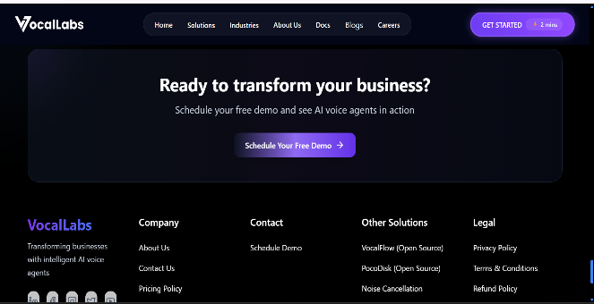  Vocallabs.ai promotes demo scheduling but does not provide an instant self-serve product experience or interactive AI trial. | Voice AI products live or die by the 30-second ear test. A decision-maker evaluating three vendors will eliminate any product they cannot hear within 2 minutes. This is especially acute in India where buyers are skeptical of AI voice quality with accents and code-switching (Hindi-English). Vocallabs claims India-tuned accent handling as a moat — if that moat is real, not showcasing it is a significant missed opportunity. Not hearing the product is the single biggest friction point in the buyer journey.
(c) SHIP INSTEAD
Ship two things: (1) A 'Call now and speak to our demo agent' phone number on the homepage — prospects dial in, hear a pre-built agent handle a booking or sales scenario, and immediately validate quality. Cost is negligible relative to conversion uplift. (2) An embedded audio widget on the website with 3–4 sample calls (real estate booking, D2C COD verification, clinic appointment) that visitors can play inline. Bonus: allow visitors to type a custom script and hear it rendered in real-time (like ElevenLabs' TTS demo). This turns a passive website into a product demonstration.

4. [Features / Services] Voice Analytics Is the Hidden Moat — But There's No ROI Story Attached
(a) OBSERVED | (b) PROBLEM
Vocallabs positions voice analytics (emotion, intent, tone detection, searchable call knowledge base) as a differentiator in its feature list and on Medium blog posts. However, on the product itself there is no demo, no sample dashboard screenshot, and no quantified outcomes tied to the analytics feature — e.g., no claim like 'clients reduced escalations by 30% using sentiment alerts'. | The analytics layer is actually Vocallabs' deepest competitive advantage — it's what separates them from pure AI-calling platforms like Retell or VAPI. But without a visible ROI story, buyers treat it as a nice-to-have checkbox rather than a core purchase driver. CX and sales leads evaluating AI voice tools are primarily asking 'what business outcome does this give me?' — and analytics is the answer, but only if quantified. Competitors like Observe.AI have built entire sales narratives around conversation intelligence outcomes.
(c) SHIP INSTEAD
Do three things: (1) Build a 1-page 'Analytics ROI' section on the website with 2–3 specific metrics from real customer data (anonymised if needed) — e.g., 'Clients using our sentiment alerts cut negative escalation calls by 28%'. (2) Add a sample analytics dashboard screenshot or interactive mockup so buyers can visualise the output before signing a contract. (3) In sales decks and case studies, lead with the analytics story, not the agent feature. The framing shift: 'Vocallabs doesn't just run calls — it turns every call into actionable intelligence.' This reframes the product from a cost-saving automation to a revenue-generating intelligence layer, which commands a higher ACV.

5. [Potential Collaborations] SDK / n8n Integration Exists But Is Invisible — Missing a Developer GTM Motion
(a) OBSERVED | (b) PROBLEM
Vocallabs has published an SDK (vocal-sdk on GitHub), an official n8n community node (n8n-nodes-vocallabs), and a Chrome extension for tab recording. These are real, meaningful integrations. However, none of these appear on the main website, in the navigation, or in any prominent marketing material. A developer visiting vocallabs.ai would not know the SDK exists. | Developers and no-code power users (n8n, Make/Integromat users) are a high-leverage GTM channel for voice AI products — they build integrations, publish workflows to community galleries, create YouTube tutorials, and drive organic discovery. Bolna, VAPI, and Retell have built entire communities around their developer APIs. By hiding its SDK and n8n node, Vocallabs is leaving a viral, low-CAC acquisition channel completely untapped. The n8n community alone has 40,000+ active automation builders who are exactly the profile that would deploy a voice agent into a workflow.
(c) SHIP INSTEAD
Three moves: (1) Add a 'For Developers' section to the website with SDK docs, quickstart code samples, and the n8n node link. (2) Publish a 'Vocallabs + n8n' template to the official n8n workflow templates gallery — a ready-to-use 'AI Voice Follow-Up on New Lead' workflow that any n8n user can deploy in one click. This alone could drive hundreds of organic installs. (3) Partner with CRM tools popular in India (Zoho CRM, Leadsquared, DhiWise) for native integrations — a 'Vocallabs for Zoho' listing in the Zoho Marketplace puts the product in front of the exact ICP (India SMB sales ops) with near-zero acquisition cost.

Framework: Porter's Five Forces on Vocallabs:
Applied to validate the strategic severity of the 5 feedbacks above.

Force | Severity | Implication for Vocallabs
Competitive Rivalry | HIGH | Bolna, Sarvam, Yellow.ai, Retell, VAPI — all funded, all with clearer pricing and developer communities. Vocallabs competes on India-tuning moat but hasn't made it visible or defensible in marketing. → Feedback #2, #3 address this.
Threat of New Entrants | HIGH | Voice AI infra cost is dropping fast (Sarvam open-sources Bulbul TTS). New entrants can spin up an India-tuned agent in weeks. Vocallabs must accelerate its data flywheel (requires more customers → requires removing friction → Feedback #1).
Buyer Power | MED-HIGH | Enterprise buyers can negotiate; SMBs compare on self-serve price and product demos. Vocallabs' demo-gated funnel gives buyers no way to self-evaluate, which paradoxically increases buyer power by forcing them through a sales call where they can demand discounts.
Supplier Power | MED | Dependency on underlying TTS/ASR (likely ElevenLabs, Sarvam, or Deepgram). If Sarvam pivots to enterprise-only, Vocallabs faces cost shock. Mitigated by building multi-model routing (as Caller.digital does). → Not in the 5 feedbacks but worth monitoring.
Threat of Substitutes | MED | Telecalling agencies and human BPO remain cheaper for low-volume, complex conversations. Vocallabs must quantify ROI clearly to justify AI over human → Feedback #4 addresses the analytics ROI story.

TL;DR — What I'd Own on Day 1:
If I join, these are the 3 bets I'd push to ship in the first 60 days:

- Pricing page + sandbox tier — removes the single biggest conversion blocker, unlocks developer GTM, and forces the team to have a clear value-per-minute story.
- A 'call this number' live demo on the homepage — Vocallabs' strongest asset is the quality of its India-tuned voice. Let people hear it in 30 seconds without a sales call.
- 3 vertical landing pages (real estate, D2C, healthcare) — turns undifferentiated traffic into vertical-qualified leads and enables targeted paid acquisition with measurable CAC.

The common thread: Vocallabs has real, defensible product moats (India-first tuning, full-stack analytics, data flywheel). The gap is that these moats are invisible to buyers. The five feedbacks above are primarily about making the product legible — to ICPs, to developers, and to the market.

Vocallabs.ai Product Teardown · Product Intern Assignment 2026

